ITSC 305 – Reverse Engineering of IoT Devices

Lab 5

Coleton Sanheim

2022-04-24

Part 1:

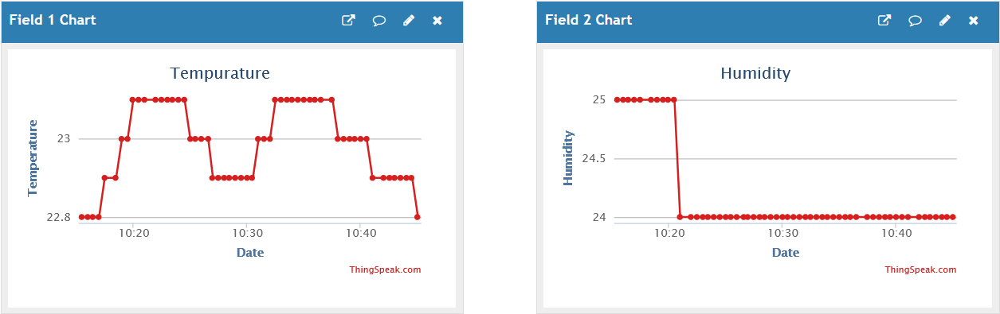

Here is the Temperature and Humidity captures from the thinkspeak portal.

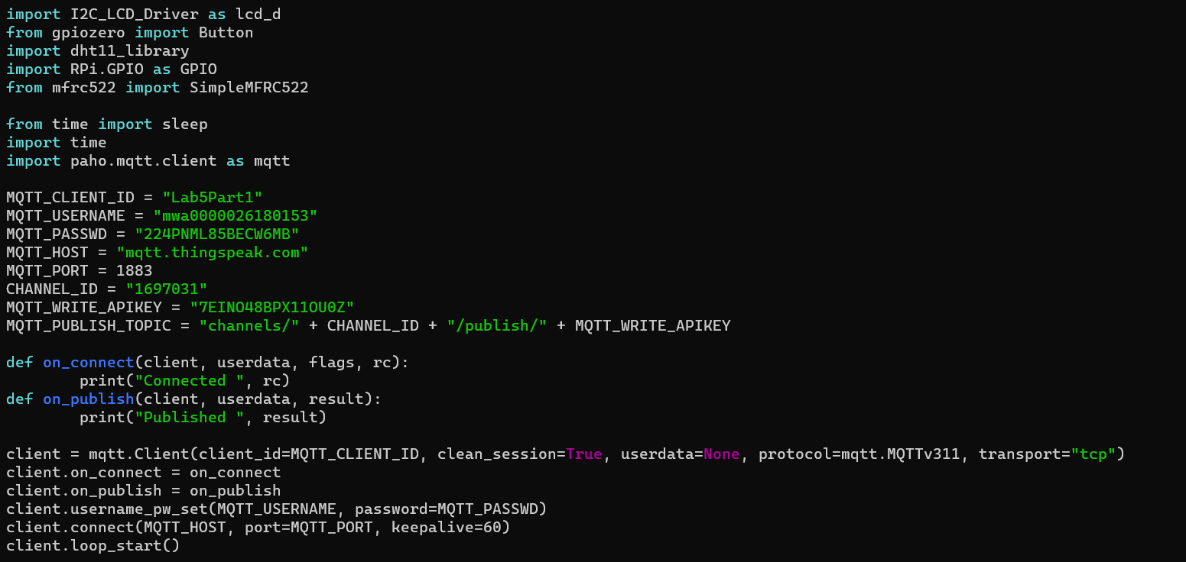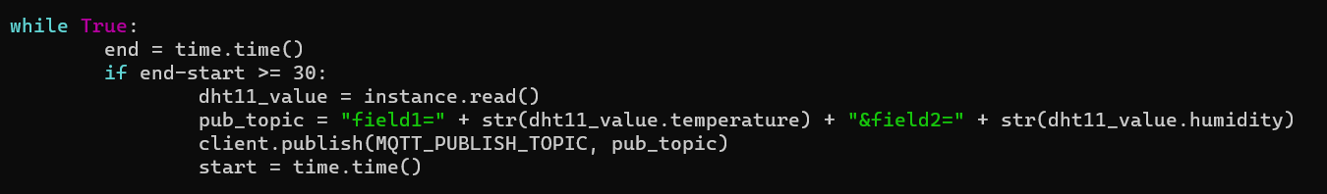

Here is the code I created to publish to thingspeak. The code is the same as the one we created for the previous lab so I only provided the code that was added or changed.

Part 2:

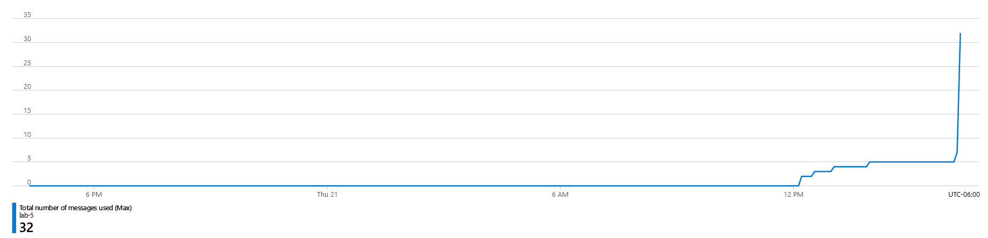

Here is the screen capture from the Azure portal that showcases messages being received. Note that the values are not recorded as I am using a free Azure account.

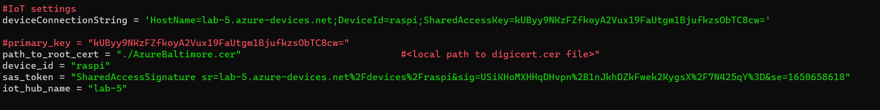

This is the code that published the data to Azure hub. Note that I only provided the section of the code that I altered as the code I used was the code that was provided by the instructor.

Critical Reflection:

For part 1 there wasn’t any problems setting up an account on thingspeak, it was pretty user friendly. When it comes to the code, I thought I would run into a problem with my code since thingspeak only takes an input every ~30 seconds and to put a sleep() command in my code would freeze the whole menu system. I realised however that I could simply record the time elapsed using time.time() and using a similar method to what we used in an earlier lab to record how long a button is held down.

For part 2 setting up an account with Azure was the hardest part as it definitely was not user friendly or easy to understand what you were supposed to do. The code I used was provided so I cannot really comment on the difficulty of that, however it does seem to be relatively similar to that of the thingspeak code.